Study plan for classes and object
________________________________________________________

Date | Topic assignment
20 –oct-2024 | 10 theory interview question and 9 programs
21 - OCT 2024 | 10 theory question and 8 program
22 – OCT -2024 | 7 program from second slot
23 –OCT -2024 | 7 program from second slot

1). WAP to create the class name as Circle with a following methods
class Circle
{
void setRadius(float radius)//accept the radius
{
}
void showArea()
{ //write here calculation logics of circle area and display it
}
}
public class AreaApp
{
public static void main(String x[])
{
//create here object of scanner and accept the radius as input
//create the object of area and call setRadius and pass radius input as parameter
//call showArea() for display the display the area
}
}

2.Create the Class Name as Rectangle with a following methods and write its logics.
class Rectangle
{ void setLengthWidth(int len,int wid)//accept the radius
{
}
void showArea()
{ //write here calculation logics of circle area and display it
}
}
public class AreaApp
{ public static void main(String x[])
{ //create here object of scanner and accept the length and width as input
//create the object of Rectangle and call setLengthWidth and pass radius input as parameter
//call showArea() for display the display the area
}
}
3. WAP to create the class Employee with a following methods
class Employee
{ void setPersonalInfo(String name,int id,int basicSal)
{ //in this function we need to store name ,id and basicSal in instance variable
}
void setProgressPer(int progress)
{ //if progress value is greater than 60 per then increase the basic salary of
//employee with 30 percentage
}
void show()
{//in this function we need to show the all details of employee like as
//name id and basic salary as well as incremental salary and total salary of employee
}
}
public class AreaApp
{
public static void main(String x[])
{ // here create the object of Scanner class and accept the name id and basic salary as well
//progress per value not need to calculate it by using formual directly enter e.g 70
//means 70%
//create the object of Employee class and call setPersonalInfo and pass name id and salary
// in it as well as setProgressPer() and pass progress value in it
//call the show() method of Employee class.
}
}
4. WAP to create the class name as Student with a following methods
class Student
{ void setSubMarks(int s[])
{ //here we need to store the array in instance variable
}
void calculatePer()
{ //here we need to call the aggregate of six subjects marks through the array and calculate its per and store in instance variable.
}
void checkGrades()
{ //here we need to check grades means per>75 && per<=100 then student in distinction if per>60 && per<=75 then in first division if per>=50 && per<=60 then second division and if per>40 && per<=50 then in third division and if per <40 then student failed
}
}
public class StudentApp
{ public static void main(String x[])
{ //create the object of scanner class
//declare the array with 6 six of type integer and store input values in array as subject marks
//create the object of Student class and call the setSubMarks() function and pass array in it
//then call calculatePer() student function
//then call checkGrades() function for checking the grading of students.

}
}
5.WAP program create the class name as Sum with a following methods
class Sum
{ void calSum(int ...x) //method with var-args
{//here we need to calculate the sum of all elements
}
}
public class SumApplication
{ public static void main(String x[])
{//here we need to create the object of Sum class and call the calSum() method and pass
//parameter in it
}
}
6. create the class name as ConvertToUpper with a following methods
class ConvertToUpper
{ char c[];
void setCharArray(char ch[])
{ //here accept the character array and store in instance variable in character array
c=ch;
}
void convertToUpperCase()
{ //here we need to write the manual logics for converting lower case array
//to upper case
}
}
public class ConvertToUpperApp
{
public static void main(String x[])
{ //here declare the fix array with a some character e.g char ch[]=new char[]={"good"};
//here create the object of ConvertToUpper class
//call setCharArray() function and pass ch array in setCharArray() function
//call convertToUpperCase() function and see the result
}
}

7.WAP to create the class name as InsertArrayEle with a following methods
class InsertArrEle
{ int c[];
void setIntArray(int ch[])
{ //here accept the integer array and store in instance variable in integer array
c=ch;
}
void insertValueOnIndex()
{ //here we need to write the manual logics for inserting value on specified index in arr
}
}
public class ConvertToUpperApp
{
public static void main(String x[])
{ //here create the array with 6 six size and store only five value in it using scanner
// create the object of InsertArrEle class
//call the setIntArray function
//call the insertValueOnIndex() and write the manual logics
}
}

8.WAP to create the class name as ArrayFeqCount with a following methods
class ArrayFeqCount
{ int c[];
void setIntArray(int ch[])
{ //here accept the integer array and store in instance variable in integer array
c=ch;
}
void countFeqCount()
{ //here we need to write the manual logics for inserting value on specified index in arr
}
}
public class ConvertToUpperApp
{
public static void main(String x[])
{ //here create the array with 6 six size and store only value in it using scanner
// create the object of ArrayFeqCount
//call the setIntArray function
//call the countFeqCount() and write the manual logics
}
}
9.WAP to create the class name as Seller with a following functions
class Seller
{
void acceptSellingCostPrice(int sp,int cp)
{ //here we need to store the sp and sp values in instance variable
}
void showProfitLoss()
{ //here we need to write the logics for profit and loss
}
}
class SellerApp{
public static void main(String x[])
{ //here we need to create the object of Scanner class
//declare the two values sp and cp and store values in it using scanner
//create the object of Seller class
//call its acceptSellingCostPrice function and pass two values in it
//call the showProfitLoss() function
}
}
10) WAP to create the pojo class name as Student class with a following methods and data or variable/state
class Student
{ int id;String name;float per;
int totalFees;int disFees;
int actualPaidFees;
void setId(int id)
{ this.id=id;
}
int getId()
{ return id;
}
void setName(String name)
{ this.name=name;
}
String getName()
{ return name;
}
//do setter and getter for all students
}
Create the class name as DiscountFees and this class is depend on Student class means in this class we need to write a method setStudent() and accept the reference of Student class in it
As well as we need to define two another method in this class name as checkDiscountEligibility(int per) -> this function accept the per of student if per greater than 60 then student is eligible for discout and give the 30% discount on fees and update in student object
And we need to write one more function in DiscountFees class show() and in this function contain the logics for display the all details of Students with discounted fees
Following sample code gives the completed structure about the two class with empty methods.
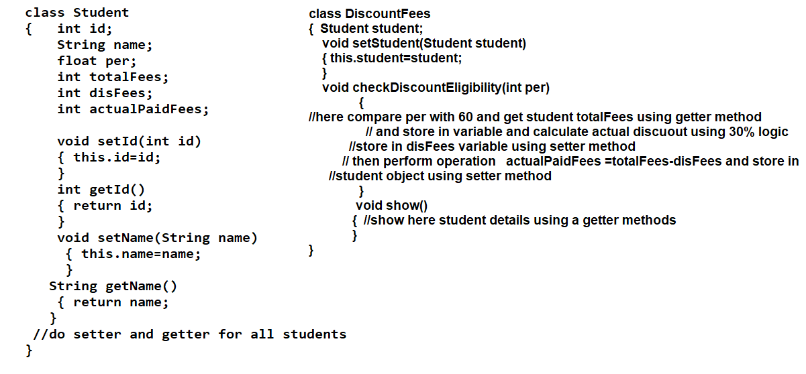
Also create the main method class with a following operation given below.
public class StudentDiscountApp
{
public static void main(String x[ ])
{ //create the object of Scanner class
//declare the variables for id,name ,per,totalFees,per and accept the input and store its value in variable usign scanner
//create the object of student class and store the values in object using setter methods
//create the object of DiscountFees class and call setStudent() method and pass student class reference in it
//call the checkDiscountEligilibility() method and pass per in it accepted from keyboard
//call show() method here
}
}

11).WAP to create the class name as Product with a following properties
class Product
{ private int id;
private String name;
private int qty;
private int rate;
public void setId(int id)
{ this.id=id;
}
public int getId()
{ return id;
}
public void setName(String name)
{ this.name=name;
}
public String getName()
{ return name;
}
//write the setter getter
// for qty and rate
}
Create the another class name as CalculateBill and this class is depend on product but we want to pass more than one product details to CalculateBill class so here we use the var-args concept.
So your class look like as
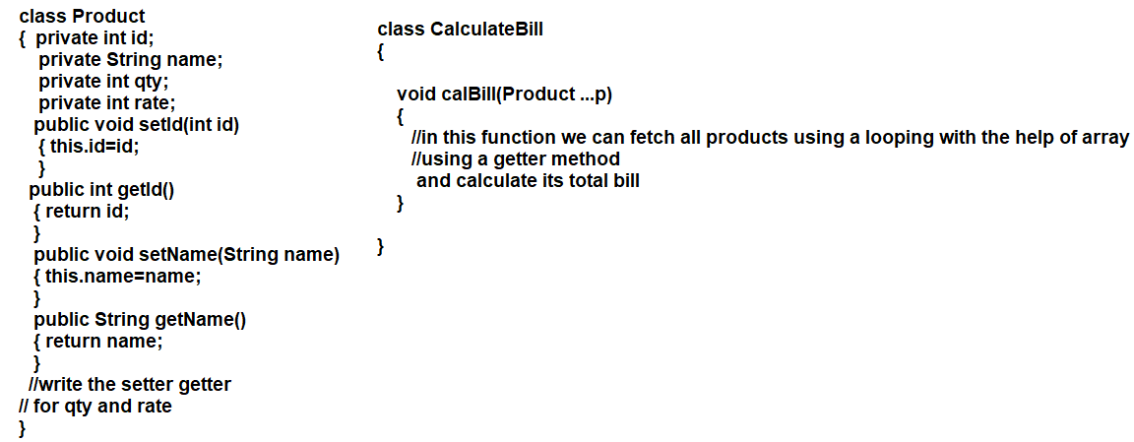
Then we need to write the class with a main method look like as
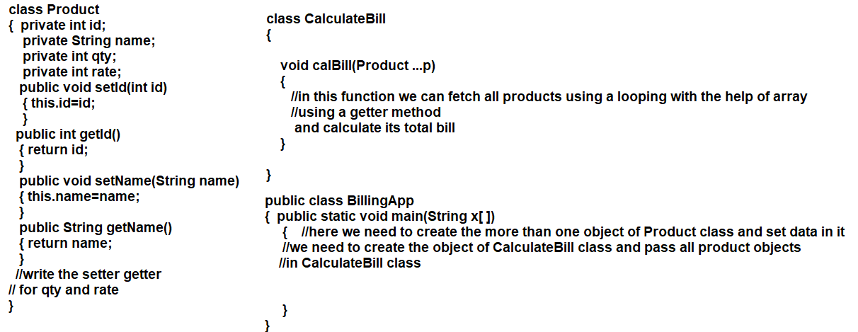
Your output look like as :
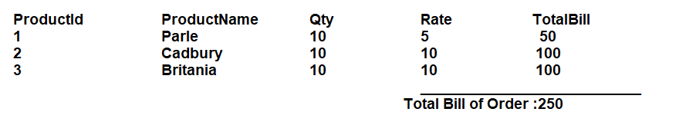
12).WAP to create the class name as Player with a setter and getter method with a Player details.
class Player
{ private int id;
private String name;
private int runs;
public void setId(int id)
{ this.id=id;
}
public int getId()
{ return id;
}
public void setName(String name)
{ this.name=name;
}
public String getName()
{ return name;
}
public void setRuns(int runs)
{ this.runs=runs;
}
public int getRuns()
{ return runs;
}
}
Create the one more class name as Team and pass Player objects in Team class using a var-args concept and show the Player details in Team class.
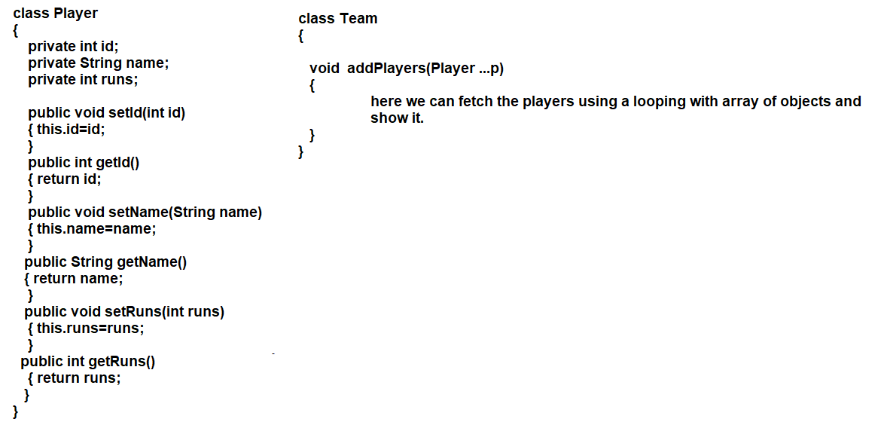
Then we need to create the class with a main method and write the code with a following logics
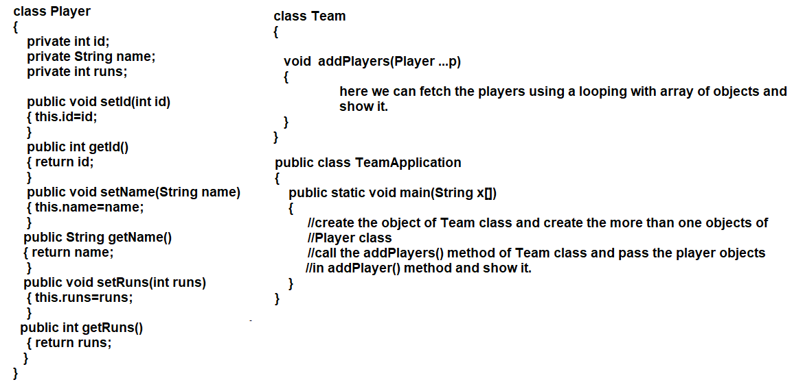

13).WAP to create the class name as PrintMatrix with a two methods void acceptTwoDArray(int x[][]) and showMatrix() sample code given below
class PrintMatrix
{ int a[][];
void acceptTwoDArray(int x[ ][ ])
{ //here we store the two dimensional array in instance variable declared as two d in class e.g a
a=x;
}
void showMatrix()
{ //here we can display the matrix logics
}
}
public class PrintMatrixApp
{
public static void main(String x[])
{ //here we need to declare the two dimensional array with a 3 x 3 and store all values in it using a Scanner class
//create the object of PrintMatrix class and call the acceptTwoDArray() function and pass two d matrix in it
//call the showMatrix() function for display the matrix.}
}
14).WAP to create the class name as MarixMultiplication with a following methods
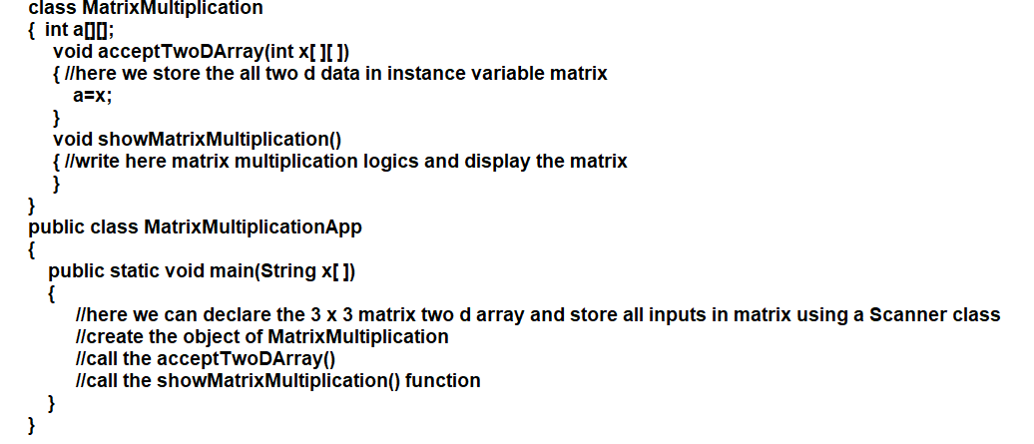
15) WAP to create the class name as Employee with a following setter and getter method and create the array of objects with a 5 elements or values and store data in it and show it.
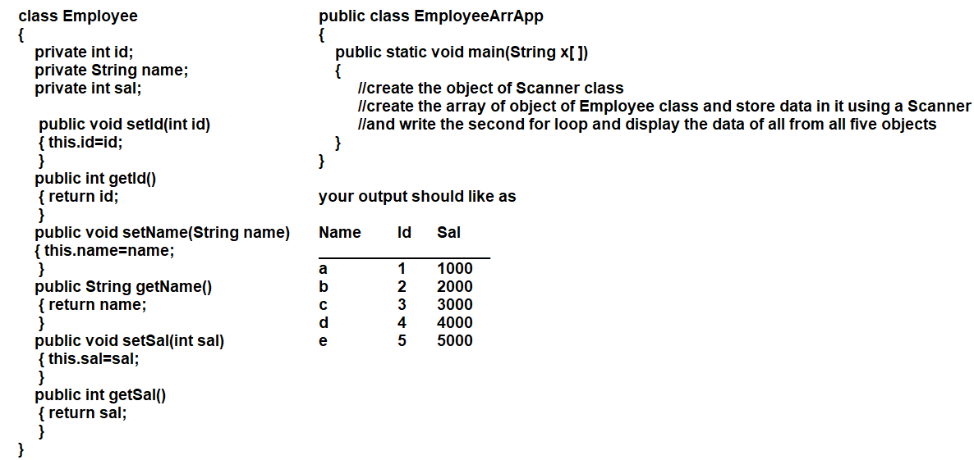
16) WAP to create the class name as Employee class and create the array object of Employee class of size 5 and store all data in it and arrange all employee data in ascending order salary wise.
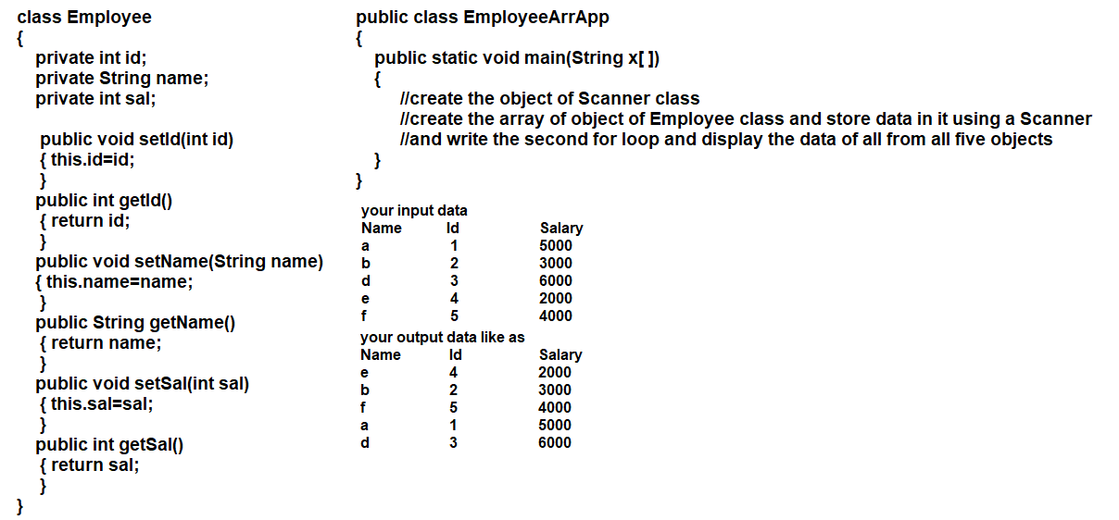

17) WAP to create the class name as Employee class and create the array object of Employee class of size 5 and store all data in it and delete the specified employee data using employee id
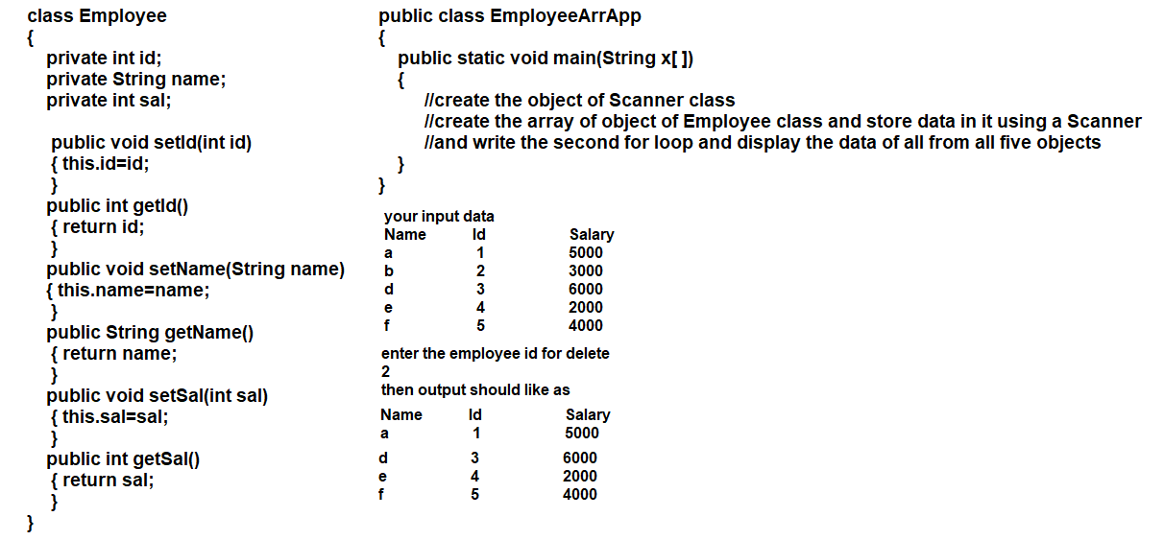

Interview Question on classes and objects
___________________________________________________________
Q1. what is class and why use it?
Q2. How we can reuse class more than one time?
Q3. what is encapsulation and explain encapsulation with real time scenario?
Q4. what is diff instance variable, static variable and local variable?
Q5. what is static keyword and explain static variable, static method?
Q6. Explain any 4 important points related with static and instance variable?
Q7. what is method variable arguments?
Q8. what is array of object and how create array of object in java?
Q9. what is Meta section and why use it?
Q10. is It true static variable not stored in object?
Q11. is it true static variable stored in Meta section?
Q12. is it true instance variable allocate memory after object?
Q13. is it true we cannot declare class as private, static and protected?
Q14. what is nested class?
Q15. What is constructor and why use constructor?
Q16. Explain types of constructors?
Q.17. what is constructor overloading explain with example?
Q18. What is constructor chaining and explain this() constructor?
Q19. What is singleton class and how to create it ?
Q20. What is utility class in java and how to create it?

Programs based on Plain Old Java Object (POJO) Class:-
============================================================================
1) Write a Java program to create a class called "Book" with attributes
for title, author, and ISBN, and methods to add,view,show,update and remove
book record from array of object ,ask size of array of object from user.

2) Write a Java program to creating a Plain Old Java Object (POJO) class
named Employee to represent an employee in a company.
The class should encapsulate the following attributes and operations:

Attributes:
name (String): The name of the employee.
jobTitle (String): The job title of the employee.
salary (double): The salary of the employee.
Methods:
1 Constructor: A constructor that initializes the employee's attributes (name, job title, and salary).
2 Getters: Getter methods for each attribute to retrieve their values.
3 updateSalary(double newSalary): A method that updates the employee's salary to a new value.
4 applyRaise(double percentage): A method that calculates and applies a percentage
raise to the current salary.
5 hasHigherSalary(Employee other): A method that compares the salary of the
current employee with another employee and returns true if the current
employee has a higher salary.
6 isEligibleForBonus(): A method that checks if the employee is eligible for
a bonus based on their salary (e.g., salary greater than $50,000).
7 getFormattedSalary(): A method that returns the salary as a formatted string (e.g., "$75,000.00").
8 displayInfo(): A method that prints the employee's information, including name, job title, and formatted salary.

3)Create a Plain Old Java Object (POJO) system for a banking application that includes the following classes and functionality:
Class: Account
The Account class should represent a bank account and contain the following attributes and methods
Attributes:
accountNumber (String): The unique identifier for the account.
accountHolderName (String): The name of the account holder.
balance (double): The current balance in the account.
Methods:
A constructor to initialize the attributes.
Getter methods for each attribute.
A method deposit(double amount) to add money to the account.
A method withdraw(double amount) to withdraw money from the account, ensuring that the balance does not go negative.
A method displayAccountInfo() to print the account details.

Class: Bank
The Bank class should manage a collection of Account objects and include the following methods:
Methods:
A method addAccount(Account account) to add a new account to the bank.
A method removeAccount(String accountNumber) to remove an account from the bank based on the account number.
A method findAccount(String accountNumber) to search for an account by its number and return it.
A method totalBalance() to calculate and return the total balance of all accounts in the bank.
A method displayAllAccounts() to print the details of all accounts in the bank.

4) Create a Plain Old Java Object (POJO) system for managing traffic lights in a traffic control application. The system will consist of a TrafficLight class with specific attributes and methods to simulate the behavior of traffic lights.
Class: TrafficLight
Attributes:
color (String): Represents the current color of the traffic light (e.g., "red", "green", "yellow").
duration (int): Represents the duration (in seconds) for which the light will stay in the current color.
Constructor:
A constructor that initializes the color and duration attributes.
Methods:
changeColor(String newColor, int newDuration):A method that changes the current color of the traffic light to a new color and updates the duration.
isRed():A method that checks if the current color of the traffic light is red. Returns true if the color is red; otherwise, returns false.
isGreen():A method that checks if the current color of the traffic light is green. Returns true if the color is green; otherwise, returns false.
displayStatus():A method that prints the current status of the traffic light, including its color and duration.
5) Develop a Plain Old Java Object (POJO) system to manage flight information for airplanes. The system will include an Airplane class with specific attributes and methods to handle flight details and status.
Class: Airplane
Attributes:
flightNumber (String): Represents the unique identifier for the flight (e.g., "AA123").
destination (String): Represents the destination city of the flight (e.g., "New York").
departureTime (LocalTime): Represents the scheduled departure time of the flight.
Methods:
Constructor:A constructor that initializes the flightNumber, destination, and departureTime attributes.
checkFlightStatus(LocalTimecurrentTime):A method that checks the flight status based on the current time. Returns a message indicating whether the flight is on time or delayed.
isDelayed(LocalTimecurrentTime):A method that checks if the flight is delayed. Returns true if the current time is after the departure time; otherwise, returns false
displayFlightInfo():A method that prints the details of the flight, including flight number, destination, and departure time.
6) Develop a Plain Old Java Object (POJO) system to manage a music library. The system will include a MusicLibrary class that stores a collection of songs and provides various operations to manipulate the library.
Class: Song
Attributes:
title (String): The title of the song.
artist (String): The name of the artist or band.
duration (int): The duration of the song in seconds.
Methods:
Constructor: Initializes the attributes.
Getters: Methods to retrieve the title, artist, and duration.
displayInfo(): Prints the song's details.
Class:MusicLibrary
Attributes:
songs (List<Song>): A collection of Song objects representing the music library.
Methods:
Constructor: Initializes the songs collection.
addSong(Song song): Adds a new song to the library.
removeSong(String title): Removes a song from the library based on the title. If multiple songs have the same title, remove the first occurrence.
playRandomSong(): Selects and plays a random song from the library (simulated by printing the song details).
displayAllSongs(): Prints details of all songs in the library.

7) Develop a Plain Old Java Object (POJO) system to manage movie information. The system will include a Movie class that contains attributes for the movie title, director, actors, and reviews, along with methods to manage and retrieve reviews.
Class: Movie
Attributes:
title (String): The title of the movie.
director (String): The name of the movie's director.
actors (List<String>): A list of actors in the movie.
reviews (List<String>): A list of reviews for the movie.
Methods:
Constructor: Initializes the attributes.
addReview(String review): Adds a new review to the list of reviews.
getReviews(): Returns a list of all reviews.
displayMovieInfo(): Prints the movie's details, including title, director, actors, and reviews.

8) Develop a Plain Old Java Object (POJO) system to manage restaurant menu items and ratings. The system will include a Restaurant class that contains attributes for menu items, their prices, and ratings, along with methods to manipulate the menu and calculate average ratings.
Class: MenuItem
Attributes:
name (String): The name of the menu item (e.g., "Pasta").
price (double): The price of the menu item.
rating (double): The rating of the menu item (from 0 to 5).
Methods:
Constructor: Initializes the attributes.
Getters: Methods to retrieve the name, price, and rating.
Class: Restaurant
Attributes:
menuItems (List<MenuItem>): A collection of MenuItem objects representing the restaurant's menu.
Methods:
Constructor: Initializes the menuItems collection.
addMenuItem(MenuItem item): Adds a new menu item to the restaurant's menu.
removeMenuItem(String name): Removes a menu item from the restaurant's menu based on its name. If multiple items have the same name, remove the first occurrence.
calculateAverageRating(): Calculates and returns the average rating of all menu items.
displayMenu(): Prints details of all menu items in the restaurant.

9) Develop a Plain Old Java Object (POJO) system to manage travel reservations, including flights and hotels. The system will include a TravelAgency class that provides functionalities to search for flights and hotels, as well as book and cancel reservations using arrays.
Class: TravelAgency
Attributes:
flights (String[]): An array of available flights (e.g., "Flight AA123 to New York").
hotels (String[]): An array of available hotels (e.g., "Hotel Paradise in Los Angeles").
bookedFlights (String[]): An array of booked flights.
bookedHotels (String[]): An array of booked hotels.
Methods:
Constructor: Initializes the arrays of flights and hotels.
searchFlights(String destination): Searches for flights to a specified destination and prints available flights.
searchHotels(String city): Searches for hotels in a specified city and prints available hotels.
bookFlight(String flight): Books a specified flight if available.
bookHotel(String hotel): Books a specified hotel if available.
cancelFlight(String flight): Cancels a specified booked flight.
cancelHotel(String hotel): Cancels a specified booked hotel.
displayBookings(): Displays all booked flights and hotels.

10) Develop a Plain Old Java Object (POJO) system to manage courses, including a base class Course and a subclass OnlineCourse. The system will include functionalities to store course details and check if an online course is eligible for a certificate based on its duration.
Class: Course
Attributes:
courseName (String): The name of the course (e.g., "Java Programming").
instructor (String): The name of the instructor (e.g., "Dr. Smith").
credits (int): The number of credits the course is worth.
Methods:
Constructor: Initializes the attributes.
displayCourseDetails(): Displays the course details.
Updating Course Details: A method to update course details (e.g., instructor name).

Class: OnlineCourse (Subclass of Course)
Attributes:

platform (String): The platform where the course is offered (e.g., "Coursera").
duration (int): The duration of the course in hours.
Methods:
Constructor: Initializes the attributes (including those from the base class).
displayCourseDetails(): Overrides the method to include platform and duration.
isEligibleForCertificate(): Checks if the course duration is greater than or equal to a specified threshold (e.g., 40 hours) to determine eligibility for a certificate.
Course:
displayCourseDetails()
updateInstructor()
OnlineCourse:
displayCourseDetails() (overridden)
isEligibleForCertificate()
getDuration()
CourseManagement:
calculateAverageDuration()
findCourseByName()

11) Develop a Plain Old Java Object (POJO) system to manage buildings, including a base class Building and subclasses ResidentialBuilding and CommercialBuilding. The system will include functionalities to store building details and calculate total rent based on specific attributes.
Class: Building
Attributes:
address (String): The address of the building (e.g., "123 Main St").
numberOfFloors (int): The number of floors in the building.
totalArea (double): The total area of the building in square meters.

Methods:
Constructor: Initializes the attributes.
displayBuildingDetails(): Displays the building details.
Class: ResidentialBuilding (Subclass of Building)
Attributes:
numberOfApartments (int): The number of apartments in the building.
rentPerApartment (double): The rent for each apartment.
Methods:
Constructor: Initializes the attributes (including those from the base class).
calculateTotalRent(): Calculates and returns the total rent for the residential building.
displayBuildingDetails(): Overrides the method to include specific residential building details.

Class: CommercialBuilding (Subclass of Building)
Attributes:

officeSpace (int): The total office space in square meters.
rentPerSquareMeter (double): The rent per square meter of office space.
Methods:
Constructor: Initializes the attributes (including those from the base class).
calculateTotalRent(): Calculates and returns the total rent for the commercial building.
displayBuildingDetails(): Overrides the method to include specific commercial building details.

Create an array of Building objects that includes both ResidentialBuilding and CommercialBuilding instances.
Implement the main method to demonstrate the following:
Creating instances of Building, ResidentialBuilding, and CommercialBuilding.
Displaying the details of each building.
Calculating and displaying the total rent for each building type.

12) Develop a Plain Old Java Object (POJO) system to manage events, including a base class Event and subclasses Seminar and MusicalPerformance. The system will include functionalities to store event details, display them, and check for conflicts based on the event date and time.
Class: Event
Attributes:
eventName (String): The name of the event (e.g., "Tech Seminar").
eventDate (String): The date of the event (e.g., "2024-10-30").
eventLocation (String): The location of the event (e.g., "Conference Hall A").
Methods:
Constructor: Initializes the attributes.
displayEventDetails(): Displays the event details.
isConflict(Event otherEvent): Checks if two events conflict by comparing their dates.
Class: Seminar (Subclass of Event)
Attributes:
numberOfSpeakers (int): The number of speakers at the seminar.
Methods:
Constructor: Initializes the attributes (including those from the base class).
displayEventDetails(): Overrides the method to include specific seminar details.
Class: MusicalPerformance (Subclass of Event)
Attributes:
performerList (String[]): The list of performers in the musical performance.

Methods:
Constructor: Initializes the attributes (including those from the base class).
displayEventDetails(): Overrides the method to include specific performance details.
Create an array of Event objects that includes both Seminar and MusicalPerformance instances.
Implement the main method to demonstrate the following:
Creating instances of Event, Seminar, and MusicalPerformance.
Displaying the details of each event.
Checking for conflicts in the event schedule.
13) Develop a Plain Old Java Object (POJO) system to manage reservations, including a base class Reservation and subclasses ResortReservation and RailwayReservation. The system will include functionalities to store reservation details, modify them, and check the reservation status.
Class: Reservation
Attributes:
reservationID (String): Unique identifier for the reservation (e.g., "RES123").
customerName (String): The name of the customer making the reservation.
date (String): The date of the reservation (e.g., "2024-10-30").
status (String): The status of the reservation (e.g., "Confirmed", "Pending").
Methods:
Constructor: Initializes the attributes.
displayReservationDetails(): Displays the reservation details.
checkStatus(): Returns the status of the reservation.
modifyReservation(String newDate): Modifies the reservation date.

Class: ResortReservation (Subclass of Reservation)
Attributes:
roomNumber (int): The room number for the resort reservation.
Methods:
Constructor: Initializes the attributes (including those from the base class).
displayReservationDetails(): Overrides the method to include specific resort reservation details.
Class: RailwayReservation (Subclass of Reservation)
Attributes:
seatNumber (int): The seat number for the railway reservation.
Methods:
Constructor: Initializes the attributes (including those from the base class).
displayReservationDetails(): Overrides the method to include specific railway reservation details.
Additional Operations:
Cancel Reservation: Implement a method in the Reservation class to cancel a reservation (change status to "Cancelled").
Modify Customer Name: Allow modification of the customer's name in both subclasses.

Create an array of Reservation objects that includes both ResortReservation and RailwayReservation instances.
Implement the main method to demonstrate the following:
Creating instances of Reservation, ResortReservation, and RailwayReservation.
Displaying the details of each reservation.
Modifying reservation details (date and customer name).
Checking reservation status.
Cancelling a reservation.

14) Develop a Plain Old Java Object (POJO) system to manage gym memberships, including a base class GymMembership and a subclass PremiumMembership. The system will include functionalities to store membership details, calculate fees, check for special offers, and perform additional operations.
Class: GymMembership
Attributes:

memberName (String): The name of the gym member (e.g., "John Doe").
membershipType (String): The type of membership (e.g., "Basic", "Standard").
duration (int): The duration of the membership in months
Methods:
Constructor: Initializes the attributes.
calculateFees(): Calculates membership fees based on type and duration.
checkSpecialOffers(): Checks for any special offers based on membership type.
displayMembershipDetails(): Displays the membership details.
modifyMembershipType(String newType): Modifies the membership type.

Class: PremiumMembership (Subclass of GymMembership)
Attributes:
personalTrainerAvailable (boolean): Indicates if a personal trainer is available.
spaAccess (boolean): Indicates if the member has access to spa facilities.

Methods:
Constructor: Initializes the attributes (including those from the base class).
calculateFees(): Overrides the method to include premium fees.
displayMembershipDetails(): Overrides the method to include specific premium membership details.
Additional Operations:
Check Trainer Availability: A method to check if a personal trainer is available.
Modify Spa Access: A method to modify spa access availability.
Create an array of GymMembership objects that includes both GymMembership and PremiumMembership instances.
Implement the main method to demonstrate the following:
Creating instances of GymMembership and PremiumMembership.
Displaying the details of each membership.
Calculating membership fees.
Checking for special offers.
Modifying membership details.

